- First of all, be sure the fabric on top of fabric roller like picture 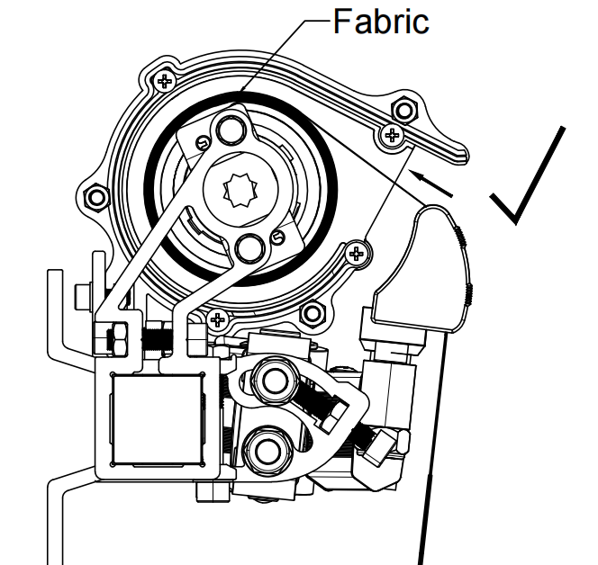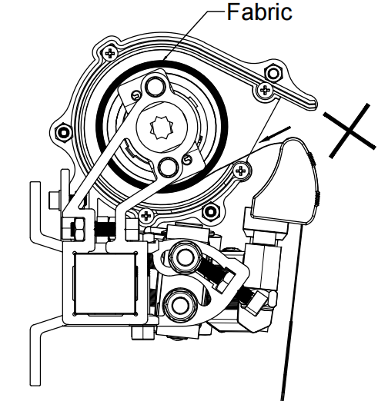
- after installing awning, don’t let it power-on first, just extend the awning to half way with crank.
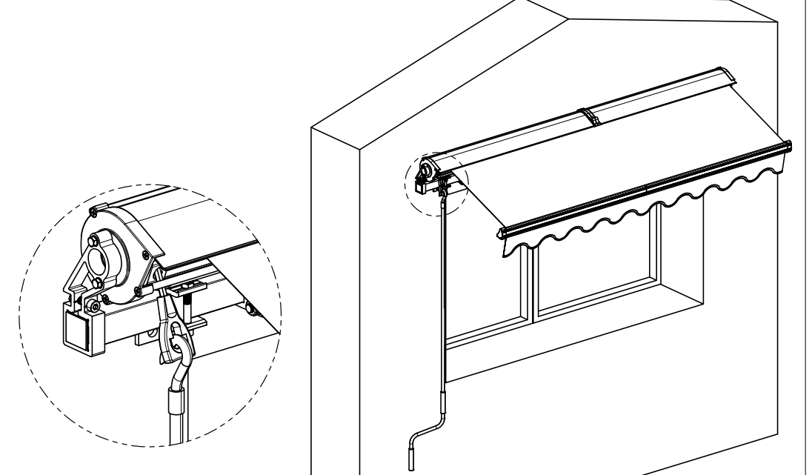
- keep awning power-on, press emitter to retract the awning a bit, then press pause button(middle button) to stop it, reduce the retract limit with plastic tube by turning button on motor to arrow -, till the awning wouldn’t retract back even press button on emitter, then add retract limit by turn button on the motor to arrow + little by little till the awning close to its perfect position. 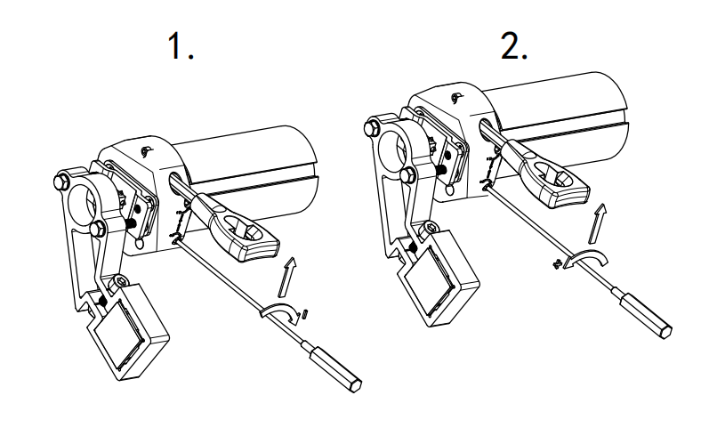
- Then press button on emitter to extend the awning to half way or less, then press pause button on emitter, reduce extend limit with plastic tube by turn button on motor to arrow - till the awning wouldn’t extend anymore even press emitter to extend the awning, then turn the same button to arrow + little by little till the awning extend fully.